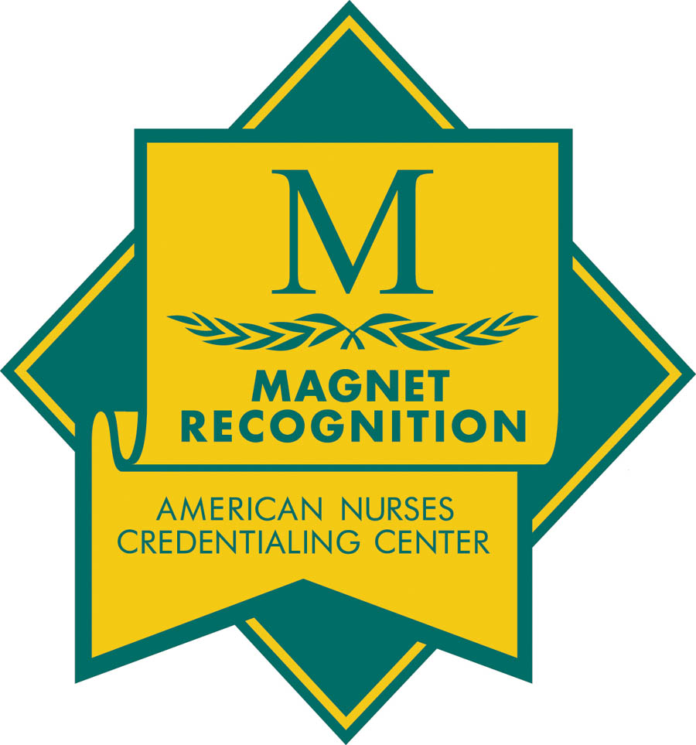


22 South Greene Street
Baltimore, MD 21201

THE UNIVERSITY OF MARYLAND MEDICAL CENTER
PATIENT SAFETY FACTSHEET

- Patient safety is everybody’s work.
- Leaders ensure that our culture supports safety and blame free reporting.
- Staff follow policies, talk to each other, report safety risks including near misses, and exercise care and caution.
- Patients/families inform their caregivers of their full history, report risks they observe, accept responsibility for consequences of decisions they make.

NATIONAL PATIENT SAFETY GOALS
- Improve the accuracy of patient identification by accurately identifying the individual for whom the service and treatment is intended.
- Improve the effectiveness of communication among caregivers.
- Improve the safety of using medications.
- Reduce the risk of healthcare associated infections.
- Accurately and completely reconcile medications across the continuum of care.
- Reduce the risk of patient harm resulting from falls.
- Encourage patients’ active involvement in their own care as a patient safety strategy.
- Improve recognition and response to changes in a patient’s condition.
- Universal Protocol: Prevent wrong site, wrong procedure, wrong person surgery and procedures.

INFECTION CONTROL
- Hand hygiene is the single most important procedure for the prevention of health care associated infections.
- When having contact with a patient, staff must wash their hands before and after contact.
- Alcohol based hand rubs can be used if hands are not visibly soiled.
- Use antimicrobial (CHG) soap and water and wash for 15 seconds if hands are visibly soiled.
- Do not use alcohol based hand rubs for patients that have Clostridium difficule (C-diff).
- Include the patient and family in our Hand Hygiene Campaign.
- Be familiar with your unit’s hand hygiene performance: GOAL-100% compliance. Be a role model for others.

EMPLOYEE INJURY/EXPOSURE
- What do I do after a needle stick/body fluid exposure?
  - Wash the area with soap and water. For mucous membrane exposures, irrigate the affected area with saline.
  - Call the Exposure Hotline immediately at 8-BEEP ID# STIK (7845).
  - Contact your supervisor.
  - Contact Environmental Services through SOSC for replacement of needle boxes.

MANAGEMENT OF PATIENT ON ISOLATION PRECAUTIONS
- If the nursing assessment reveals that the patient may have a communicable disease (e.g. diarrhea of unknown etiology, signs and symptoms of a viral respiratory illness), the nurse can initiate presumptive isolation precautions and then follow-up with the physician for an order.
- Isolation attire is not to be worn outside the patient room unless the staff is transporting a patient on precautions.
- An isolation cart is acceptable in the hallway only if the patient has a visible isolation sign.
- Isolation signage must be in accordance with the hospital policy; handwritten signs are unacceptable.

TB EXPOSURE PREVENTION
- Tuberculin skin testing is required annually; if you are known to be positive, an annual screening questionnaire must be completed.
- If you are exposed to a patient with tuberculosis, a follow-up skin test 10-12 weeks after exposure is required.

I have read and understood the University of Maryland Patient Safety Factsheet and I do voluntarily sign said document of my own accord and as a condition of being allowed to participate in the Observership.

_______________________________________________________
Participant Signature

________________________________________________________ ____________________________
Printed Name Date

Please email this completed form and send to STC observation Program @ stcobservation@umm.edu.

